CSS Design RAG v2: Mask Matching, Knowledge Graph and Retrieval Plan
Oct 27, 2026 · @phani ivatury
A historic substation counts as a match only when it fits the new site on every detail the query provides:
- Geometry: its substation footprint (the room for an indoor substation, the marked area for an open-to-sky one) matches the area and shape marked on the builder's plan.
- Metadata:
  - the floor or floors the substation is on
  - centralised or distributed
  - one substation or several, and how many
  - indoor or open to sky
  - standalone or inside a building
  - on a platform or not
  - basement or earth below
  - voltage and CSS type (DT, metering, package, pad-mounted)
- Equipment: it has the requested types, counts, ratings and sizes.
- Structure: its equipment, cutouts and doors sit where the new plan's beams, columns and cutouts allow them.
- Cables and access: its trench paths and cable entries fit the new trench route and road side.
- Everything else extracted: every other field that exists in both the CSS record and the query, such as heights, clearances, platform, ventilation and site context.
V2 is built on the knowledge graph from the original proposal. Every historic substation is a subgraph typed by the ontology, carrying its metadata, equipment, relations and polygons. The query is turned into a graph of the same shape and matched against each candidate subgraph:
- vertices are paired through the ontology and their attributes
- relations are checked edge by edge
- polygons are compared after aligning both substations in one mm frame
Text and image embeddings only shortlist candidates. The ranking uses only the details the query provides. Nothing is implemented yet; the input is the reviewed extraction JSON from the extraction v2 plan.
In this plan, “room” and “substation” mean the same thing: the substation footprint, which is the room when indoor and the marked area when open to sky.

Query inputs and the presence rule
A query can be any mix of chat requirements and builder drawings. The builder drawings go through the same extraction v2 pipeline, so the query and the historic designs are described in the same JSON.
Query input | Where it comes from | Used for
Equipment list (types, counts, kVA, ways) | Chat | Equipment match, catalogue footprint and height
Installation, floor, centralised / distributed, platform | Chat or extraction | Filters and metadata match
Marked substation area (polygon) | Builder site plan | Footprint shape and area match
Beams and columns in or over the area | Builder structural / floor plan | Conflict with historic equipment and cutouts, clear height
Planned cutouts | Builder plan | Cutout-to-cutout and cutout-to-equipment match
Doors and access side, wayleave, DP road | Builder site plan | Door wall and orientation match, site context
Trench route | Builder site plan | Trench path match
Heights (floor to floor, beam bottom) | Builder section or chat | Height feasibility
Presence rule. A feature takes part in ranking only when the query provides it.
- Missing from the query: the feature's weight is zero and the remaining weights are re-normalised.
- Missing from a historic design: the feature is skipped for that design. The design gets a coverage value, the share of the query's weight it could be judged on, which is shown beside the score and used to break ties. It never lowers the score directly.
- A query with masks but no chat requirements is still ranked on geometry alone.

Features in the index
Each historic design is indexed per substation, with its extracted masks put into the room's own mm frame. The features come from the extraction v2 JSON.
Category | Masks (polygons in mm) | Attributes
Electrical configuration and equipment | Equipment footprints, each with its type, label and front side | Types and counts, kVA (written or catalogue-matched), ways, L×B×H, weight, clearances per side
Site constraints | Substation footprint, building footprint, DP road, internal road, compound wall, nalla, structures, trees | Area, aspect, shape class, floor, installation, centralised / distributed, beneath (basement / earth), plot clearances
Civil and structural | Beams, columns, cutouts, platform, trenches inside the room | All heights from the chosen section, platform height and steel, beam bottom, cutout sizes, trench width and depth
Cable routing and connectivity | Trench paths, cable trays, pipe entries, risers | Route length, entry side, which equipment each entry serves
Access and ventilation | Doors, rolling shutters, fire exits, louvres, wayleave, access paths | Sizes, wall (N, S, E, W relative to the room), door facing the road, wayleave width and length
The index also stores derived spatial relations, each a fact both the graph and the scorer use:
- cutout under equipment
- beam over equipment
- column inside the room
- door on a wall facing the road
- trench from the door or wall to the road

Retrieval pipeline
The query goes through the same extraction as the historic designs. A cheap shortlist picks about 20 candidates, and only those are aligned and scored in full.
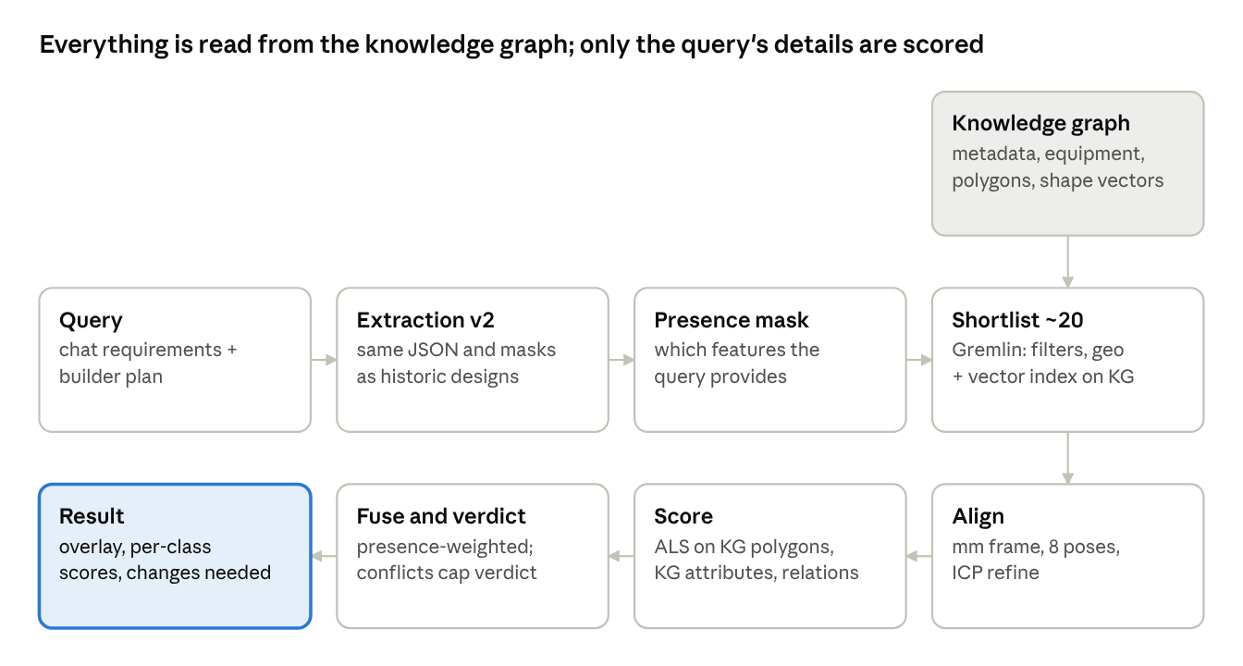
retrieval pipeline · query to verdict

Geometric matching of masks
The metric is the Aligned Layout Score (ALS). It asks two questions after the two rooms are aligned:
- Similarity: how alike are the two layouts?
- Compatibility: would the historic layout work inside the new room's beams, columns, cutouts and doors?
Plain IoU of whole images is not used. Small offsets would wipe it out, and a missing class would count as a mismatch.

1. Alignment
- One frame. Put both rooms in mm, with the origin at the footprint centroid. Scale is never normalised, so a 40 m² room is not made to look like an 80 m² one.
- Eight poses. Rotate the candidate onto the query's principal axis, then try 4 rotations × 2 mirror images.
- Refine. Adjust each pose by up to ±10° and a small shift (ICP on the boundary points).
- Pick the pose. Keep the pose with the best footprint overlap. Where both sides have a door or road side, poses that put them on the same wall get a bonus. The pose is stored for the overlay.

2. Per-class similarity
Mask class | Comparison | Tolerance
Substation footprint | Area ratio, shape IoU after equal-area scaling, aspect | Area τ = 0.15 (log ratio)
Equipment (per type) | Set matching, below | Centroid σ = 500 mm
Cutouts | Set matching | σ = 300 mm
Columns | Set matching on points | σ = 300 mm
Doors, rolling shutters, fire exits | Set matching + same wall | σ = 500 mm along the wall
Louvres | Count and wall per side | —
Beams, trenches, cable trays (line-like) | Mean chamfer distance between centrelines, plus direction | σ = 400 mm, 15°
Site context (DP road, wayleave, nalla) | Direction from footprint to the feature, distance ratio | 30°, τ = 0.3
Set matching, for any class of separate masks. Query masks Q and candidate masks R are paired one-to-one with the Hungarian algorithm on pair similarity: centroid closeness, size ratio and soft IoU. Soft IoU is IoU computed after both masks are grown by the tolerance δ, so a 200 mm shift still counts.
sim(q,r) = e^{-\lVert c_q - c_r \rVert / \sigma} \cdot e^{-\lvert \ln(a_q / a_r) \rvert / 0.3} \cdot \mathrm{IoU}_{\delta}(q, r)

S_{class} = \frac{2 \sum_{(q,r) \in M} sim(q,r)}{\lvert Q \rvert + \lvert R \rvert}
This is a soft Dice over the two sets. Extra or missing masks lower it in proportion; nothing is all-or-nothing.

3. Compatibility with the builder's structure
These checks place the historic equipment, with its catalogue clearance envelope, into the query room using the chosen pose.
Check | Measure | Effect
Equipment fits the room | Share of historic equipment-plus-clearance area inside the query footprint | Score; below 0.9 is flagged
Columns | Area of historic equipment envelopes hit by query columns | Score; a column inside a transformer or RMU footprint is a conflict
Beams | For each historic item under a query beam: beam bottom ≥ item height + catalogue ceiling clearance | Share of items that pass; a fail is a conflict
Cutouts | Query cutouts matched to historic cutouts, and to historic equipment that needs bottom entry | Soft Dice, plus share of bottom-entry items with a cutout under them
Doors | Historic transformer door lands on a query wall with a door or access side, and is at least the catalogue width (2,750 mm) | Score; no usable door is a conflict
Height | Query clear height ≥ tallest historic item + 450 mm tray rule; substation height ≥ 4.2 m | Pass or fail
Trenches and cable entry | Query trench route reaches the wall or cutouts where the historic equipment takes its cables; entry side and trench width (catalogue min 750 mm) agree | Share of historic cable entries served by the query trench; no route to the transformers is a conflict
Equipment against the query requirement | Types and counts, kVA, ways, L×B×H and weight of the historic equipment vs the requested items (catalogue sizes when only ratings are given) | Score; a missing requested major item is a conflict
Plot clearances (open to sky and standalone) | Historic footprint and its door and trench placed at the query's marked location in the chosen pose; shortest distance to the query nalla, DP road, internal road, compound wall, nearby structures and trees vs the norms (nalla 6,000, DP road 4,500, internal road 1,500, compound 1,500, structure 6,000 mm; trees 1.5 m, 4.5 m at doors) | Share of norms met; any violation, nalla first, is a conflict with the shortfall in mm
A conflict does not remove the design. It caps the verdict at “adapt”, and the overlay draws the conflict in red.
Nalla and plot clearance check for open-to-sky sites. This runs whenever the query's site plan shows a nalla or another plot feature, and is reported in two parts.
- At the new site. Can the historic substation sit at the query's marked location without breaking a clearance? A historic footprint larger than the marked area, or a pose that puts its door or bulk toward the nalla, can push it inside the 6,000 mm nalla clearance even when the marked area itself complies. The check uses the historic footprint as built. If no pose complies, the result says how far the substation would need to move, or shrink, to comply.
- In the historic design itself. Did the older substation meet its own clearances on its own site plan? The answer comes from the extraction's plot_clearances (meets_norm per feature). A historic design that violated its own nalla clearance is flagged “precedent not compliant”. It is never offered as a clean reuse, even when its geometry fits.
Both parts are stored in the graph as DISTANCE_TO {mm, norm_mm, meets_norm} edges from the substation to the nalla and other site features. A query can therefore also filter on “designs that kept 6 m from a nalla”.

4. The geometry score (S_geom, used inside the KG match)
\mathrm{ALS} = \frac{\sum_k w_k \, m_k \, s_k}{\sum_k w_k \, m_k}
Here sₖ is each class similarity or compatibility score, and mₖ is 1 only when the query provides that class and the candidate has it (the presence rule). The starting weights are set so structure dominates, and are tuned on labelled pairs.
Score | Starting weight
Footprint | 3
Equipment positions | 3
Columns and beams compatibility | 3
Cutouts | 2
Doors | 2
Height | 2
Trench path | 1
Louvres | 0.5
Site context | 1

Image features
Image features are used for recall: they pick about 20 candidates from the index fast. The aligned mask matching then makes the final decision. The current features (ink density, gradient histogram, colour fractions on the whole sheet) are replaced by two features built from the masks, plus one visual embedding.
Feature | How it is built | Compared with | Role
Canonical mask raster | Each substation's masks drawn into a 128 × 128 grid in its own mm frame (fixed 100 mm per cell), one channel per class: footprint, transformer, RMU, LT panel, cutout, column, beam, door, louvre, trench | Weighted per-channel soft IoU, over the 8 poses, using only the channels present in the query | Fast geometric recall; also the thumbnail shown in results
Shape descriptor | Footprint turning function and centroid-distance profile (64 values), plus area, aspect and convexity | Rotation-invariant distance | Footprint recall, independent of pose
Layout embedding | A pretrained vision model (DINOv2, open source) on the clean rendered mask raster, never the raw drawing | Cosine similarity; vector stored on the substation vertex in the KG | Recall for queries that come with a layout image but few attributes
Two rules keep these features from misleading the ranking:
- Raw drawings are never embedded. Line weight, colour and title-block clutter would dominate the vector.
- A channel takes part only when the query has that class. This keeps the presence rule at the recall stage too.

Knowledge graph construction
The knowledge graph is the historic index. Every piece of information used for retrieval lives on its vertices and edges: metadata, equipment, heights, clearances, polygons, shape descriptors and mask-raster vectors. Retrieval reads nothing else.
- Built from: reviewed extraction JSON only.
- Database: JanusGraph, queried with Gremlin. Storage is Cassandra or ScyllaDB locally and Bigtable on GCP. An Elasticsearch mixed index speeds up range, text and geo lookups.
- Polygons: every polygon is a property of its vertex. polygon_mm (GeoJSON in the substation's mm frame) is used for exact mask matching. geo_shape (the same polygon as a JanusGraph Geoshape) answers spatial predicates such as intersects and within, for example “column intersects transformer”.
- Vectors: the shape descriptor, canonical raster vector and layout embedding are stored as properties on the substation vertex. At 50 to a few thousand substations they are compared in the retrieval service after a Gremlin fetch. A separate vector index keyed by vertex id is added only if the corpus grows past that.
- Mask images: PNGs are kept in object storage only for display, referenced from the vertex by path.
Vertices
Vertex | Key properties
document | Source PDF, title block, scale, review status
layout | Type, name, floor, scale
substation | Floor, installation, centralised / distributed, area, heights, coverage of each feature class
equipment | Label, type, kVA and source, L×B×H, weight, position, front side
opening | Door, rolling shutter, fire exit, louvre: size, wall
structure | Beam, column, cutout, platform: size, level, position
route | Trench, cable tray, wayleave, access path: width, length, class
site_feature | DP road, internal road, nalla, structure, tree, earthing pit
Shared vertices | equipment_type, catalogue_item, facet (floor = stilt, kVA = 1500 …), concept (ontology class)
Every geometric vertex carries segment_id, its polygon in mm, and the mask path.
Edges
Kind | Edges
Structure | HAS_LAYOUT, SECTION_OF {rank}, HAS_SUBSTATION, CONTAINS, HAS_OPENING, HAS_STRUCTURE, HAS_ROUTE, ON_FLOOR
Spatial relations, computed once at load | UNDER {offset_mm} (cutout under equipment), BELOW_BEAM {gap_mm} (equipment under beam), CLEARANCE {mm, side, meets_catalogue}, ON_WALL {wall}, FACES {angle} (door to road), CONNECTS (trench from door to road), DISTANCE_TO {mm, meets_norm} (substation to site feature)
Typing | IS_A (to equipment_type and concept), MATCHES_CATALOGUE {error_pct}, HAS_FACET
Similarity, precomputed | SIMILAR_TO {als, pose} between historic substations (top 10 each), used to widen recall
The spatial edges are the main gain over v1. Patterns such as “a cutout under every transformer”, “transformer door facing the road” or “no beam over a transformer below 3.2 m” become graph facts that can be matched directly.

Ontology graph visualisation
The ontology is the schema every site graph follows. Each class is a concept vertex, linked to its family by SUBCLASS_OF; each site vertex links to its class by IS_A.
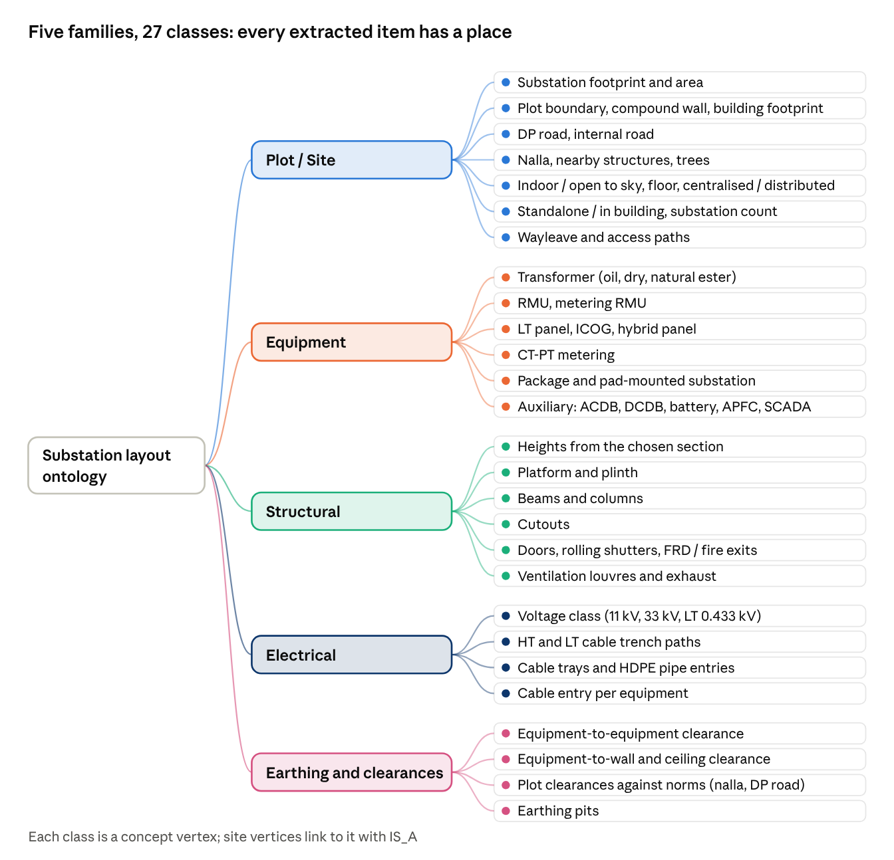
ontology · 5 families, 27 classes
In the app, the Ontology view draws this tree as an interactive mind map. Each class shows:
- its extraction status
- how many of the 50 drawings evidence it
- its fields
- where it sits in the graph
- which score uses it
Clicking a class lists the drawings that have it. The screenshot below is from the prototype built on the v1 data; v2 adds the classes in the tree above.
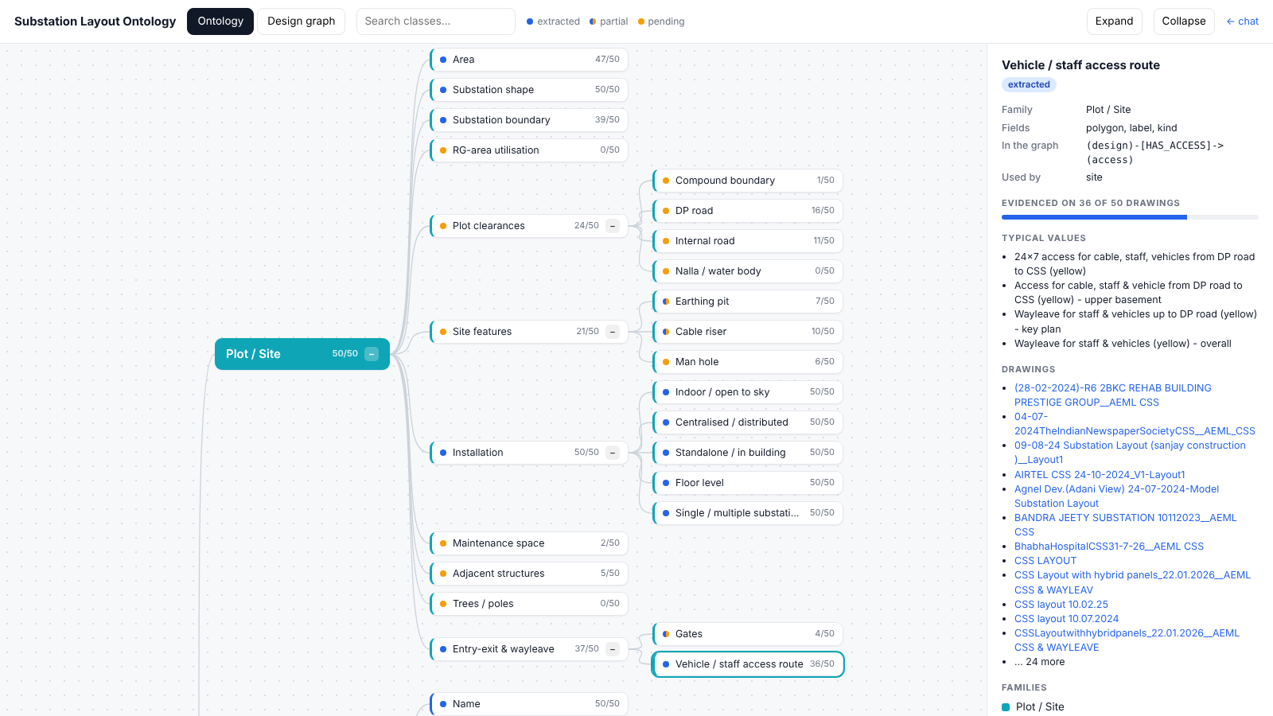

Viewing the ontology graph of one site
Every site in the index can be opened as its own ontology graph. The example below is the constructed graph for the 2BKC rehab building, drawn from its extracted values.
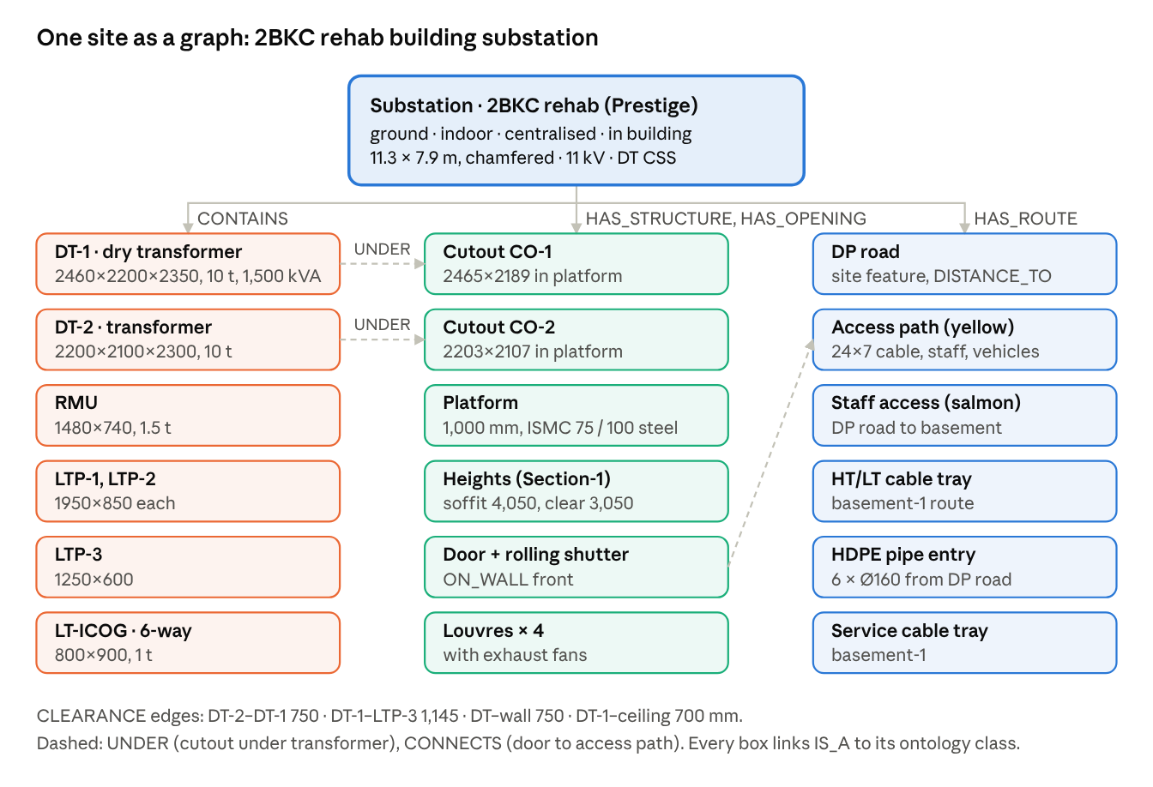
site graph · 2BKC rehab building substation
Site graph viewer (in the app, and on every search result)
- Pick a site from a searchable list (project name, drawing no., floor), or click “View graph” on any result card.
- Three linked panels:
  - the graph, grouped by ontology family
  - the drawing with the vertex's mask highlighted
  - the properties of the selected vertex or edge, and the layout or section it came from
- Layers to toggle: families, relation types (UNDER, CLEARANCE, CONNECTS, DISTANCE_TO, …), and norm checks, so a nalla or clearance violation shows in red.
- Compare view: the query graph next to a matched site graph, with paired vertices joined, and kept and broken relations colour-coded. This is how a KG ranking is explained.
- Works without the graph database: the site graph is built in memory from the extraction JSON when JanusGraph is off.
The screenshot is the prototype's per-site view for the same building.
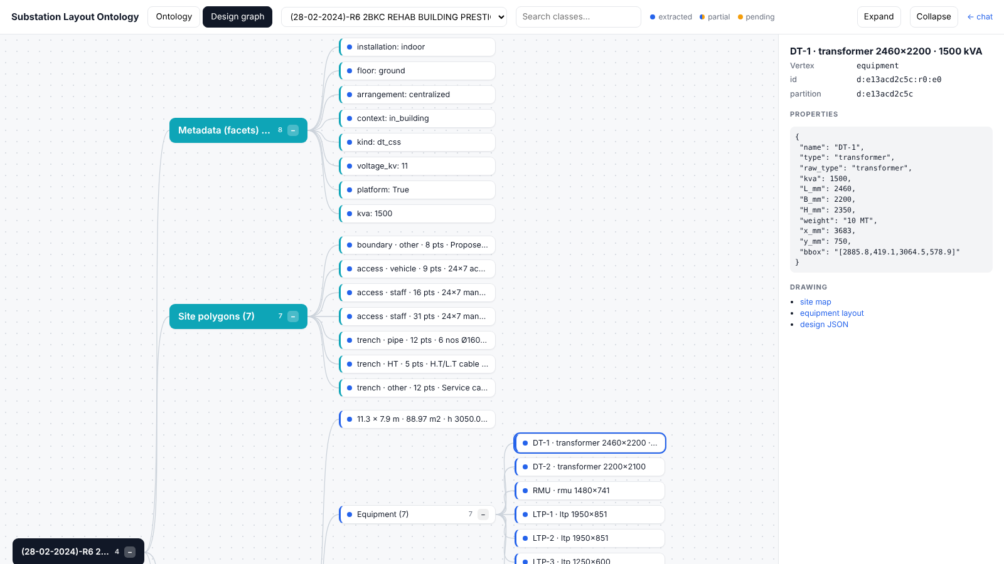

Knowledge graph matching (primary retrieval)
Retrieval is an ontology-guided match between two graphs: the query graph and each historic substation's subgraph. Both are typed by the same ontology from the original proposal, with five families: Plot / Site, Equipment, Structural, Electrical, and Earthing & Clearances. The geometric matching above, text and images all feed into this match; none of them replaces it.
- Build the query graph. Every detail the query provides becomes a vertex or edge typed by the ontology:
  - requested equipment, linked by IS_A to its equipment type
  - metadata facets: floor, centralised or distributed, installation, substation count, CSS type
  - builder masks as structure, opening, route and site-feature vertices, each with its polygon
  - relations implied by the builder plan: UNDER, BELOW_BEAM, ON_WALL, FACES, DISTANCE_TO
Nothing the query lacks is created. This is the presence rule in graph form.
- Fetch candidate subgraphs. One Gremlin traversal per candidate pulls the substation's 2-hop neighbourhood (facets, equipment, structures, openings, routes, site features and their relations, with polygons and properties). The hard filters run in the same traversal: installation type, and floor class when given.
- Match vertices. Query vertices are paired one-to-one with candidate vertices (Hungarian algorithm), class by class. Each pair's similarity combines three terms:
  - Ontology similarity: 1 for the same class, partial for sibling classes (oil DT vs dry DT, both transformers; Wu–Palmer similarity on the ontology tree), 0 across families.
  - Attribute similarity: kVA, ways, L×B×H, weight and sizes, compared as log ratios with tolerances.
  - Geometric similarity: centroid, size and soft IoU of the two vertex polygons, after the substation-level alignment pose from the geometric matching.
- Check edges. Under that pairing, each query edge is looked up in the candidate. Does the paired cutout sit UNDER the paired transformer? Is the paired door ON_WALL facing the road? Does CLEARANCE meet the catalogue? Does DISTANCE_TO the nalla meet its norm? Numeric edge properties are compared with tolerances. Each edge is weighted by rarity (IDF over the corpus) and by ontology importance, and the score is the weighted share of query edges kept.
- Add compatibility edges. The builder's columns, beams, cutouts, trench and site features are tested against the paired historic equipment, footprint and doors. This creates virtual edges, CLEARS or CONFLICTS_WITH, and the CONFLICTS_WITH edges are the conflicts shown in results.
S_{KG} = \frac{w_n m_n S_{nodes} + w_e m_e S_{edges} + w_g m_g S_{geom} + w_f m_f S_{facets}}{w_n m_n + w_e m_e + w_g m_g + w_f m_f}
Term | Meaning
S_nodes | Soft Dice of the vertex pairing (ontology × attributes)
S_edges | Weighted share of query relations kept
S_geom | The Aligned Layout Score from the geometric matching section, read from the vertex polygons
S_facets | Metadata facet match
m | 1 when the query has inputs for that term, else 0
This amounts to an approximate attributed graph edit distance:
- substitutions: paired vertices and edges, priced by ontology, attributes and geometry
- insertions and deletions: unpaired vertices
Each substation subgraph has only tens of vertices, so the match runs in milliseconds per candidate.
Shortlist. Before full matching, a cheap pass ranks all substations and keeps about 20. It uses facet overlap and equipment-type overlap from Gremlin, the shape descriptor, and the canonical raster vector, both read from the substation vertex. The SIMILAR_TO neighbours of the top hits are added.

Score fusion, verdict and explanation
The final score is S_KG from the knowledge graph match. Its four terms and starting weights:
Term | Covers | Starting weight
S_geom (Aligned Layout Score) | Footprint, equipment positions, beams and columns, cutouts, doors, trenches, height, plot clearances | 0.30
S_nodes | Requested equipment vs historic equipment (types through the ontology, kVA, ways, sizes, weight), plus structures and openings | 0.30
S_edges | Relations kept: cutout under equipment, clearances, door facing road, trench to road, distance to nalla and road | 0.25
S_facets | All metadata: floors, centralised / distributed, substation count, installation, standalone / in building, beneath, voltage, CSS type, and any other field present on both sides | 0.15
A term with no inputs from the query drops out and the other weights are re-normalised. Text and image similarity are not in the final score; they only build the shortlist.
Several substations. When the query or a historic design has more than one substation (for example 12A and 12B, or one per floor):
- Each query substation is paired one-to-one with a candidate substation by the Hungarian algorithm on their per-substation scores. Same floor is preferred.
- The design score is the mean over the pairs, multiplied by a count term. Unpaired substations on either side lower the count term, so a two-substation query ranks two-substation designs first.
- Centralised versus distributed and the substation count are also compared directly in S_attr.
S = S_{KG} \cdot c_{count}, \quad c_{count} = \frac{2 \min(n_q, n_r)}{n_q + n_r}
Here n_q and n_r are the numbers of substations in the query and the candidate. For a single-substation query and candidate, c_count = 1.
Verdict
Outcome | Rule
Reuse | S ≥ 0.80 and no conflicts
Adapt | S ≥ 0.60, or reuse blocked by a conflict
New layout needed | Below 0.60
The thresholds are set on labelled pairs (next section). Every result also shows its coverage, so a high score judged on 20% of the query is visibly weaker than one judged on 90%.
Explanation. Each result card shows:
- the overlay: the query footprint, beams, columns, cutouts and trench, with the historic equipment placed in the chosen pose; conflicts are drawn in red
- the per-class scores
- the matched graph paths
- what would need to change to reuse the design, for example “move LTP-2 600 mm east to clear the column” or “add a cutout under DT-2”

Two retrieval engines and fallback
Both engines are built and either can be switched off. Ontology graph matching is the default because the client prefers it, and its graph view is always shown. Regular RAG matching is the fallback whenever the graph path fails or returns nothing useful.
 | Ontology KG matching (default) | Regular RAG matching (fallback)
Index | JanusGraph knowledge graph, typed by the ontology | Design cards built from the same extraction JSON: attributes, polygons, BM25 text, embeddings
Scoring | S_KG: vertex pairing through the ontology, edges kept, aligned polygons, facets | Hybrid score: structured attributes, the same aligned polygon score (S_geom), keyword, semantic, image; then rank fusion and constraint rerank
Needs | A running graph database | Files only; runs in memory
Explanation | Matched graph paths and the overlay | Per-group scores and the overlay
Mode switch. retrieval_mode in the config and in the chat UI takes one of four values:
- kg: ontology matching only
- rag: regular RAG only
- auto (default): ontology first, RAG on fallback
- both: the two rankings side by side, for comparison and evaluation
Enable and disable each engine. Each engine has its own switch, engines.kg.enabled and engines.rag.enabled, independent of the mode. Both are on by default. They can be set in the config file, by environment variable (CSS_KG_ENABLED, CSS_RAG_ENABLED) or from an admin toggle in the UI. A change takes effect without a restart or rebuild.
KG engine | RAG engine | What happens
On | On | retrieval_mode applies as above (auto by default)
On | Off | Ontology matching only; no fallback. A thin or failed graph match returns “no match” with the reason
Off | On | Regular RAG only. The graph database is not contacted, and the ontology view is built in memory from the extraction JSON
Off | Off | Retrieval is off. Chat still gathers requirements and the ontology view still shows the query graph. Searches return “retrieval disabled” instead of results
A disabled engine skips its index build and load too: no graph load into JanusGraph when KG is off, no embeddings or BM25 when RAG is off. The /health endpoint and every result show which engines are on.
When auto falls back to RAG. Any one of these triggers it, and the result card says which engine ranked it and why:
- The graph database is unreachable, or a traversal times out (over 5 s).
- The query graph is too thin: fewer than 3 typed vertices or relations, for example a query with one line of text.
- The graph match returns fewer than 3 candidates above a 0.40 floor.
Visualisation always uses the ontology. Even when RAG ranks the results, the UI shows each result as an ontology graph:
- the query graph
- the matched historic subgraph, with paired vertices and kept and broken relations highlighted
- the ontology tree with the classes the query used
If the graph database is down, these graphs are built in memory from the extraction JSON with the same ontology mapping. The view never depends on the database being up.
Implementation rules
- One interface. Both engines implement the same Retriever interface: search(query) → ranked results with a shared result schema (score, verdict, conflicts, coverage, explanation, overlay). The UI and chat do not care which engine answered.
- Shared scoring library. The ontology mapping, the presence rule, polygon alignment, S_geom, attribute scorers, catalogue checks and plot-clearance checks are written once and called by both engines. The two engines therefore never disagree on what a fit or a conflict is.
- One source of truth. Both indexes are built from the same reviewed extraction JSON in one build step, so they never drift apart.
- Health and fallback are logged. Each query logs the mode, the engine used, the fallback reason and timings. A /health endpoint reports graph database status.
- Evaluation runs both. Every test is scored for KG, RAG and auto, so the team can see where the ontology engine wins and when the fallback is doing the work.

Incremental updates: ingestion separate from retrieval
The system is two services that share the stores but run on their own:
- Index update service: takes in drawings and updates the indexes.
- Retrieval service: answers queries.
A new drawing never needs a full rebuild, and retrieval keeps serving while updates run. The update service will be wired into AEML's systems later, but its interface is fixed now.
Inputs: PDF, DWG or DXF, one file or many
Format | Adapter | Status
PDF | Render pages, vector text and colours, then the two Astra passes | Built first
DXF | Read layers, blocks, polylines and dimension text directly as vector geometry, so masks and labels come out exact. Also render to an image for the Astra passes and the viewer | Later; same output JSON
DWG | Convert to DXF (ODA File Converter or LibreDWG), then the DXF adapter | Later
All three produce the same extraction JSON, so nothing after extraction depends on the input format. A PDF and its DWG for the same site are linked as one document, and the DWG version wins on geometry when both exist.
Ways in
- Single upload: one file in the app, or POST /ingest.
- Bulk upload: a folder, a zip, or a list of paths via POST /ingest/batch. Each file becomes its own job.
- Watched folder: an optional drop folder that the service polls, for later integration.
Per-file job
- Register. The file is hashed (sha256) and assigned a document id. A file seen before is skipped; a new version of a known drawing (same project, newer revision) is linked to the old one.
- Extract. Extraction v2 runs on the file and writes its folder: JSON, masks, crops and raw replies.
- Review gate. The job stops at auto status until it is reviewed, or is indexed straight away as provisional, depending on a setting. Provisional designs are searchable but labelled, and are never offered as “reuse”.
- Upsert into the graph. The design's old subgraph is deleted by partition key, then the new one is added in one transaction: vertices, edges, polygons, vectors, IS_A links to the ontology. Shared vertices (facets, equipment types, catalogue items) are reused, not duplicated.
- Upsert into the RAG index. The design card, BM25 entry, embedding and mask raster are added or replaced. BM25 and embeddings update per document, with no full rebuild.
- Refresh what depends on the corpus. Rarity weights (facet and relation frequencies) are updated as counters. SIMILAR_TO edges are recomputed only for the new design against its shortlist.
- Publish. The index version number goes up by one. Retrieval reads a consistent version: a query that starts on version 41 finishes on 41 even if version 42 lands mid-query.
Bulk runs process jobs in parallel, up to the Astra rate limit, and publish one version at the end of the batch. A failed file does not stop the batch; it is listed with its error and can be retried alone.
Removing and replacing. A drawing can be withdrawn, which removes its subgraph and card and bumps the version, or replaced by a new revision. History is kept so a past result can still be explained.
Full rebuild remains available for schema or ontology changes and for catalogue updates that change derived values such as catalogue-matched ratings. It rebuilds from the stored extraction folders without re-running Astra.
Status. Each job has a status (queued, extracting, awaiting_review, indexed, failed) visible in the app and through GET /ingest/{job_id}. Retrieval responses carry the index version they used.

Evaluation and calibration
The current self-retrieval test (each design used as its own query) stays as a smoke test. Three more checks are added.
- Engineer-labelled pairs. For about 20 query sites (builder plans with a known final design), an engineer grades the top 10 candidates as reuse, adapt or not useful. These drive the weights, the tolerances (σ, δ, τ) and the 0.80 / 0.60 thresholds. The measures are nDCG@5 and reuse recall@3.
- Perturbation tests. Each historic design is used as a query after changes:
  - shift the cutouts by 200 to 800 mm
  - add a column inside a transformer footprint
  - lower the beam bottom by 500 mm
  - shrink the room by 10%
  - drop whole classes
The score must fall smoothly for small shifts and flag a conflict for the structural changes. Dropping a class must not change the ranking of the classes that remain.
- Ablation. Measure ranking with and without each part: ALS, attributes, graph, and the image recall stage. This shows what each part adds and keeps the weights honest.

Risks and open questions
- Mask quality bounds retrieval quality. A missed column or misplaced cutout changes the compatibility score directly. Only reviewed JSON is indexed, and each mask's confidence scales its weight.
- Builder plans are in a different form. Developer plans often lack legends and use other layer colours. The query side may need a short confirm step in the chat: the user ticks the extracted beams, columns and cutouts before ranking.
- Alignment ambiguity. Square or symmetric footprints give near-tied poses. Door and road side break most ties; the rest are shown as alternative overlays.
- Small corpus. With 50 designs, graph rarity weights and learned weights can overfit. Weights stay hand-set until the labelled pairs exist.
- Input format: uploads can be PDF, DWG or DXF. The PDF path is built first, and both historic drawings and builder plans go through the full extraction v2. The DWG and DXF adapters plug into the same interface once the PDF pipeline works.

